INDUSTRIAL TRAINING REPORT

# The Complete 2023 Web Development Bootcamp

Submitted in partial fulfillment of the Requirements for the award of

### Degree of Bachelor of Technology in Computer Science & Engineering

Submitted By

**Name: VAIBHAV BHALLA**

**University Roll No. 03314802721**

### SUBMITTED TO:

Department of Computer Science & Engineering MAHARAJA AGRASEN INSTITUTE OF TECHNOLOGY GGSIPU, DELHI



# CERTIFICATE OF COMPLETION

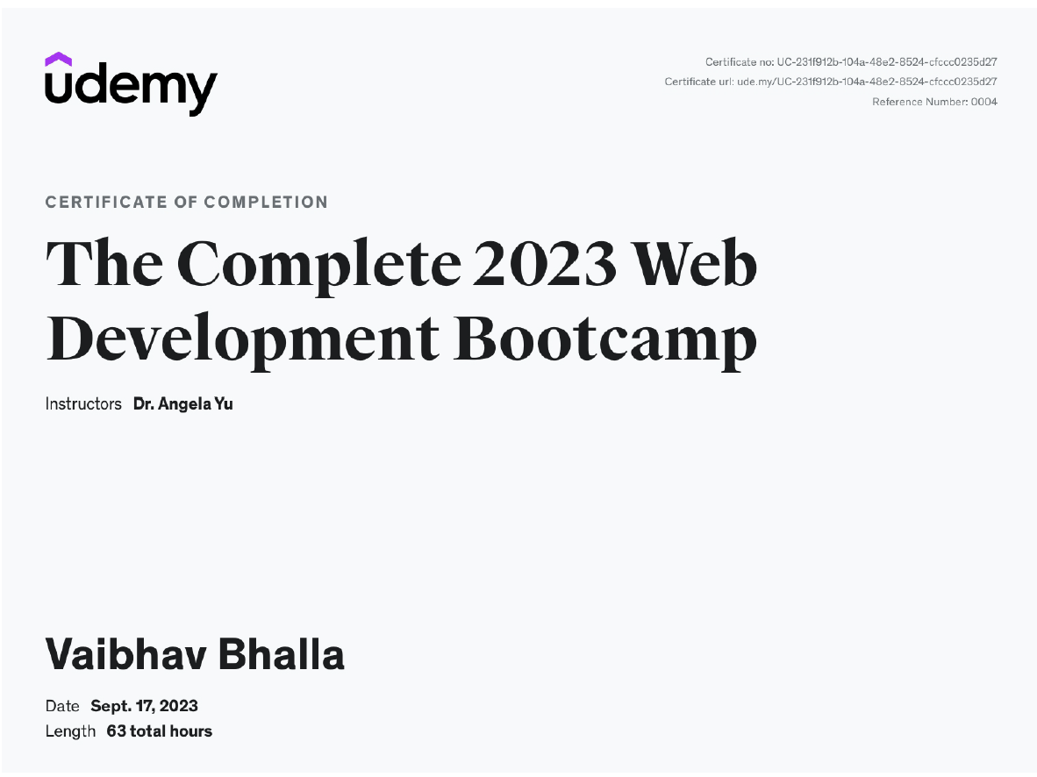

**DECLARATION**

I hereby declare that the Training Report entitled “The Complete 2023 Web Development Bootcamp” an authentic record of my own work as requirements of 6 weeks Training during the period from 30th July, 2023 to 17th September, 2023 for the award of degree of B.Tech. (Computer Science & Engineering), GGSIPU, under the guidance of Dr. Angela Yu (Developer & Lead Instructor).

#### Name:VAIBHAV BHALLA

#### RollNo.03314802721

**Date :**

Certified that the above statement made by the student is correct to the best of our knowledge and belief.

**Signatures Examined by:**

#### (Faculty Coordinator)

**Head of Department**

# ACKNOWLEDGEMENT

I, Vaibhav Bhalla, a computer science and engineering student at the Maharaja Agrasen Institute of Technology, New Delhi, am incredibly appreciative to Dr. Angela Yu for her trust in me and for entrusting me with my training, "The Complete 2023 Web Development Bootcamp," with particular reference to Udemy. I am privileged to take this opportunity to thank Dr. Angela Yu for her timely provision of materials and insightful advice that enabled me to successfully complete my course.

I would like to thank Mrs. Namita Gupta (HOD, CSE) for organising the summer training on time. My sincere thanks goes out to Ms. Prerna Sharma, my mentor, for her unwavering encouragement, support, and direction. The Maharaja Agrasen Institute of Technology, New Delhi faculty members in the Computer Science & Engineering department are also to be thanked for their invaluable assistance and direction, without which this training would not have been feasible.

My gratitude and acknowledgement also extend to my friends, who voluntarily contributed their skills and insightful advice to the project's development.

Last but not least, I would want to express my sincere respect and appreciation to my family for their steadfast assistance and collaboration during this course.

Vaibhav Bhalla

B.Tech (CSE)

3rd year

# About Company – Udemy

Udemy, a leading online learning platform, stands as a beacon of education in the digital age. With a global reach, this dynamic platform caters to both learners and knowledge sharers, making it the go-to destination for skill development.

Boasting impressive statistics as of June 2023, Udemy showcases its dedication to knowledge dissemination: a staggering 64 million learners, over 75,000 instructors, and a vast library of 210,000 courses available in 75 languages. Notably, Udemy extends its influence to 14,900 enterprise customers, emphasizing its capacity to empower organizationsof all sizes.

Udemy's curated collection of courses not only enriches individuals but also transforms companies, governments, and nonprofits by placing learning at the heart of their strategies. Inclusivity and diversity define its culture, driving both employees and learners to thrive. Mission and Vision :-

#### Improving lives through learning

Whether you want to learn or to share what you know, you’ve come to the right place. As a global destination for online learning, we empower organizations and individuals with flexible and effective skill development.

Udemy mission to enhance lives through learning, adapting to the ever-evolving modern workplace. With a finger on the pulse of the learning landscape, Udemy continues to shape the future of education.

# About Company – London App Brewery

The App Brewery, founded by Dr. Angela Yu (Developer and Lead Instructor), is a renowned institution known for its innovative and effective approach to teaching programming and app development. With a strong emphasis on project-based learning, The App Brewery empowers students to master coding by actively constructing fully functional websites and applications. Beyond technical skills, the institution places significant importance on the creation of aesthetically pleasing products, setting it apart from others.

The courses offered here not only impart coding knowledge but also guide students in crafting visually appealing, showcase-worthy projects. In addition, The App Brewery fosters motivation through built-in support systems, including student networks and valuable study tips. By offering a professional-level curriculum that encompasses industry best practices.

The App Brewery graduates have successfully secured positions at prominent tech giants such as Twitter, Google, Amazon, and Apple, underscoring the institution's achievements and influence in the programming and app development sector.

The App Brewery provides a diverse range of courses, covering various aspects of programming and app development, including:

* Complete Web Development Bootcamp
* iOS App Development Bootcamp
* The Data Science and Machine Learning Bootcamp
* The Complete Android App Development Bootcamp
* The Complete React Native and Redux Bootcamp
* The Complete Python Bootcamp
* The Complete Financial Analyst Training & Investing Course

# About Course – The Complete 2023 Web Development Bootcamp

The Complete 2023 Web Development Bootcamp, led by instructor Angela Yu, is a top- rated online course designed to transform individuals into full-stack web developers. With over 150,000 ratings and an impressive 4.8 average score on Udemy, this comprehensive program offers a staggering 65+ hours of content, making it one of the most extensive web development courses available.

Angela Yu, the lead instructor at The App Brewery, London's renowned programming bootcamp, brings the latest tools and technologies used by industry giants like Apple, Google, and Netflix into this 2023-ready course. The curriculum, refined over four years with student feedback, consists of engaging animated videos and numerous real-world projects. Over a million students have benefited from Angela Yu's teaching, making this course a go-to-choice for aspiring developers.

Covering both front-end and back-end development, the course encompasses HTML 5, CSS 3, Bootstrap 5, JavaScript ES6, jQuery, Node.js, Express.js, RESTful APIs, databases (SQL, MongoDB, Mongoose), React.js, authentication, and more. Students also explore Web3 Development, Blockchain technology, and NFT minting.

Upon completion, students gain fluency in web development, supported by a portfolio of over 32 websites. The course includes animated video lectures, coding exercises, real-world projects, quizzes, practice tests, and downloadable resources.

Testimonials from students highlight Angela Yu's exceptional teaching style and the course's structured, hands-on approach.

In summary, this course offers an unparalleled opportunity to master web development and stay updated with the latest technologies, all with the guidance of a highly-rated instructor.

**Table of Content**

|  |  |  |
| --- | --- | --- |
| ***S.***  ***No.*** | ***Content*** | ***Page No.*** |
| 1. | Acknowledgement | iv. |
| 2.1 | About Company – Udemy | v. |
| 2.2 | About Company – London App Brewery | vi. |
| 2.3 | About Course – The Complete 2023 Web Development Bootcamp | vii. |
| 3. | Abbreviations and Nomenclature | xi. |
| 4. | CHAPTERS | 12-37 |
| 4.1 | Introduction – Web Development | 12 |
| 4.2 | Tools and Technology Used | 13 |
| 4.3 | Technical Contents   1. How Websites work? 2. HTML 3. CSS 4. Bootstrap 5. JavaScript 6. Task 1: Drug Kit 7. jQuery 8. Task 2: Simon Game 9. Express with Node.js 10. Axios 11. Task 3: BoredApp 12. Database – SQL & NoSQL 13. Authentication and Security | 14-24 |
| 4.4 | Project – A Blog Website | 25-28 |
| 4.5 | Snapshots | 29-33 |
| 4.6 | Results and Discussions | 34 |
| 4.7 | Conclusions and Future Scope | 35 |
| 4.8 | Weekly Job Summary | 36-37 |
| 5. | Learning After Training | 38 |
| 6. | References | 39 |

**List of Tables**

|  |  |  |
| --- | --- | --- |
| ***S. No.*** | ***Table*** | ***Page No.*** |
| 1. | Some HTML Tags | 15 |
| 2. | CSS Properties | 16 |
| 3. | Bootstrap Properties and Tags | 17 |
| 4. | Weekly Job Summary (Week 1-6) | 36-37 |

# List of Figures

|  |  |  |
| --- | --- | --- |
| ***S. No.*** | ***Figure*** | ***Page No.*** |
| 1. | Web Development Working | 12 |
| 2. | How Website Works? | 14 |
| 3. | HTML Structure | 15 |
| 4. | Drum Kit | 19 |
| 5. | Simon Game | 20 |
| 6. | BoredApp | 23 |
| 7. | Blog Website | 29 |

**Abbreviations and Nomenclature**

1. HTML – Hyper Text Markup Language
2. CSS - Cascading Style Sheets
3. JS - JavaScript
4. DOM - Document Object Model
5. HTTP - Hypertext Transfer Protocol
6. JSON - JavaScript Object Notation
7. API - Application Programming Interface
8. URL - Uniform Resource Locator
9. CRUD - Create, Read, Update, Delete
10. DBMS - Database Management System
11. REST - Representational State Transfer
12. UI/UX - User Interface/User Experience
13. DOM - Document Object Model
14. SQL – Structured Query Language

# Chapter 1 : Introduction

**Web Development :-**

Web Development also known as website development, refers to the tasks associated with creating, building, and maintaining websites and web applications that run online on a browser. It may, however, also include web design, web programming, and database management. The basic tools involved in web development are programming languages called HTML (Hypertext Markup Language), CSS (Cascading Style Sheets), and JavaScript.

### Types of Web Development:-

There are three main types of web development:-

1. **Front-End Development**: involves the “client-facing” side of web development in creating and designing the user interface (UI) and user experience (UX) of websites andweb applications. The primary responsibility of a front-end developer is to ensure that the visual and interactive aspects of a website or application are user-friendly, aesthetically pleasing, and functionally efficient.
2. **Back-End Development:** creates the basic framework of a website before maintaining it and ensuring it performs the way it should, including database interactions, user authentication, server, network and hosting configuration, and business logic.
3. **Full-Stack Development:** refers to the end-to-end application software development,including the front end and back end. The front end consists of the user interface, andthe back end takes care of the business logic and application workflows.

Some popular languages are:

* + Front-End: HTML, CSS, JavaScript.
  + Back-End: Python, Node.js, PHP.
  + Full-Stack : MEAN stack (Mongo, Express, Angular, Node), MERN stack (Mongo,Express, React, Node).

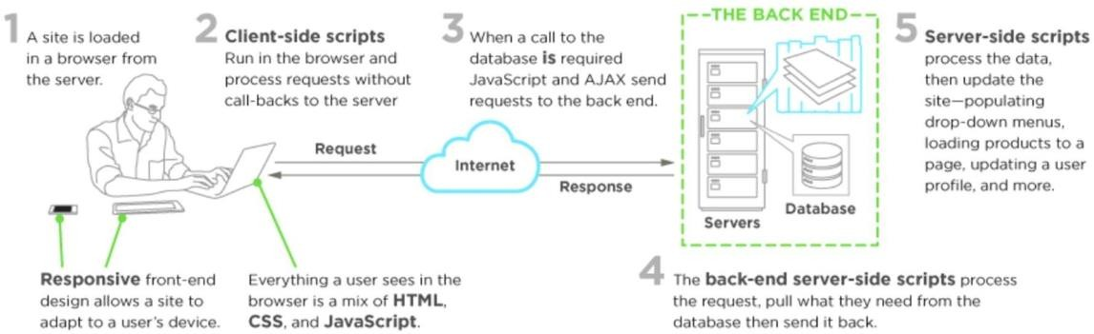

# *Webdevelopmentworking*

# Chapter 2 : Tools & Technology Used

Throughout the comprehensive course, we covered a number of tools and technologies, including:-

* Front-End Web Development

1. HTML 5
2. CSS 3
3. Flexbox
4. Grid
5. Bootstrap 5
6. JavaScript ES6
7. DOM Manipulation
8. jQuery

* Back-End Web Development

1. Node.js
2. NPM packages
3. Express.js
4. EJS
5. RESTAPIs
6. Databases – SQL and NoSQL
7. MongoDB and Mongoose
8. Authentication

# Chapter 3 : Technical Contents

## How Websites Works?

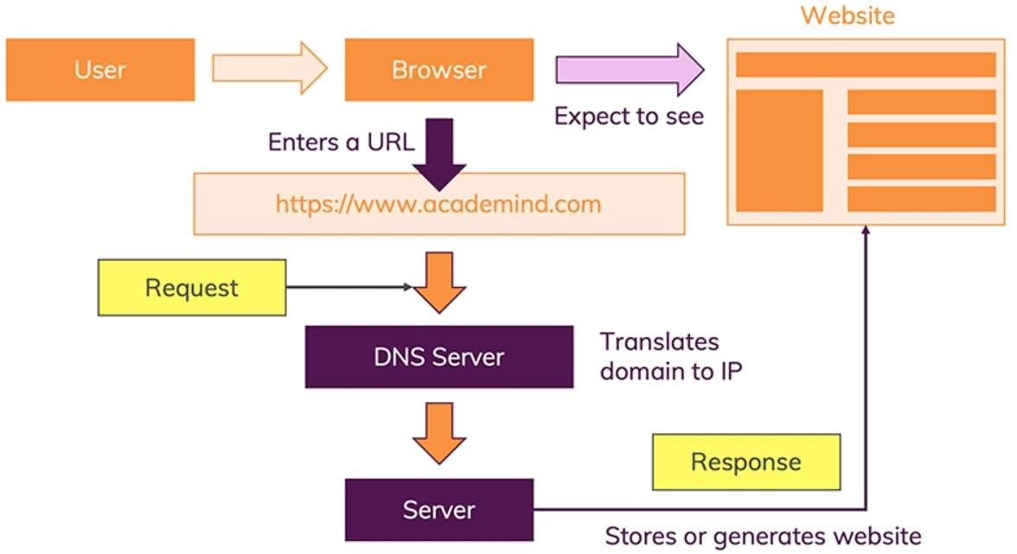

# *How website works*

When a user enters a URL into a web browser, such as "Google.com," the browser initiates a process to access the desired webpage. This process involves several key steps.

First, the browser contacts a domain name server (DNS) to translate the entered domain name into an IP address. This translation is necessary to locate the specific server hosting the requested webpage. The browser then proceeds to send an HTTP (Hypertext Transfer Protocol) request to this server, specifying the page it wants to retrieve.

Upon receiving this request, the DNS server plays a crucial role in identifying the IP address associated with the requested domain name. The browser then contacts the web server using this IP address to request the desired webpage.

It's important to note that a typical webpage requires more than just the HTML/XHTML content. It often includes additional elements like images, style sheets, and various resources to be fully functional and visually appealing. Each of these elements has its own unique URL for identification. The web server, in response to the browser's request, delivers not only the main page but also these additional files to the browser.

Finally, the browser accumulates all the received data, including the main page, images, styles, and other resources, and seamlessly compiles them into the complete webpage that is ultimately displayed to the user. This collaborative process ensures the proper loading and rendering of web content, allowing users to interact with and enjoy a rich and fully-formed webpage

## HTML

HyperText Markup Language (HTML) is used by the browser to manipulate text, images, and other content, in order to display it in the required format. HTML was created by Tim Berners-Lee in 1991.

**Elements and Tags:** HTML uses predefined tags and elements which tell the browser how to properly display the content. Remember to include closing tags. If omitted, the browser applies the effect of the opening tag until the end of the page.

Eg. <p> opening tag element, </p> closing tag element HTML structure

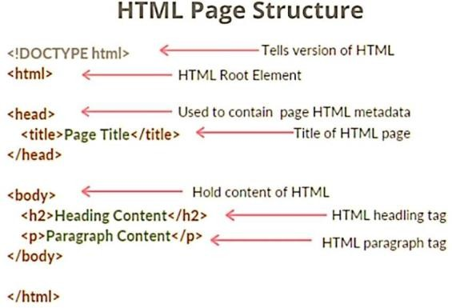

# *HTML structure*

Some common HTML Tags:-

|  |  |
| --- | --- |
| ***Tag*** | ***Description*** |
| <html>…</html> | Declares Web page to be written in HTML |
| <head>…</head> | Delimits the page’s head |
| <title>...</title> | Defines the title(not displayed on page) |
| <hn>…</hn> | Delimits a level n heading |
| <b>…</b> , <i>…</i> | Set content in boldface , italics respectively |
| <ul>...</ul>,<ol>...</ol>,  <li>… </li> | Defines Unordered (bullet) list, numbered list, item in list  respectively |
| <p> ... </p> | Defines paragraph |
| <br> , <hr> | Forces line break , inserts horizontal rule |
| <img src=”” > | Displays an image here |
| <a href = “ “ >…</a> | Defines a hyperlink |

In HTML,

* + **id :** uniquely identifies a single element on a page.
  + **class :** groups and styles multiple elements with shared characteristics.

## CSS

Cascading Style Sheets (CSS) is used to format the layout of a webpage.

With CSS, you can control the color, font, the size of text, the spacing between elements, how elements are positioned and laid out, what background images or background colors areto be used, different displays for different devices and screen sizes, and much more!

CSS can be added to HTML documents in 3 ways:

* + Inline - by using the style attribute inside HTML elements
  + Internal - by using a <style> element in the <head> section
  + External - by using a <link> element to link to an external CSS file

Important CSS Properties:-

|  |  |
| --- | --- |
| ***Property*** | ***Description*** |
| position | Specifies the type of positioning applied to an element.  (static, absolute, relative, fixed) |
| top, bottom, left, right | Position of respective edges of element |
| width, height | Specify size of element |
| background | Specifies the background color or image of an element. |
| margin, padding, border | Specify spacing and borders for an element. |
| display | Specify how or whether element is to be displayed |
| z-index | Specifies the “stacking order” of an element relative to any  overlapping elements |

Selectors in CSS:-

id selector : #id_name{properties1: value1;} class selector : . class_name{properties1: value1;}

Media Queries:-

Media queries in CSS are used to apply styles based on the characteristics of the device or viewport, such as screen width, height, and orientation. They are commonly used for creating responsive web designs. Eg. @media (max-width: 768px) {}

## Bootstrap

**Bootstrap** is a popular front-end framework that simplifies web development with pre- designed components and responsive styles.

Key concepts include:

**Grid System:** Bootstrap uses a 12-column grid system for responsive layouts. For example,

<div class="col-md-6">

**Components:** It provides pre-built UI components like navigation bars, buttons, forms, and modals.

**Responsive Design:** Bootstrap is mobile-first, ensuring your site looks great on small screens.

**Utility Classes:** It offers classes for quick styling, like text-center and bg-primary.

#### Important Bootstrap Properties and Tags:

|  |  |
| --- | --- |
| ***Property*** | ***Description*** |
| <link> and <script> tags | Include Bootstrap's CSS and JavaScript files. |
| .container and .container-fluid | Create fixed or full-width containers |
| .row | Group columns within a grid |
| .col | Determine column widths |
| .bg | : Set background colors. |
| .btn | Style buttons. |
| .form-control | Style form input fields |

**Responsive Utilities:** Bootstrap offers classes to control element visibility and alignment based on screen size. For instance, .d-none hides an element, .d-md-block shows it on medium screens, and .mx-auto center it horizontally.

Bootstrap is well-documented and community-supported, making it a powerful choice for web development.

## JavaScript

JavaScript is a high-level, dynamic, and interpreted programming language used primarily for web development. It adds interactivity and dynamic behavior to websites.

#### Key Features:-

* + Asynchronous Programming: Supports asynchronous operations, making it suitable for tasks like handling user input and making server requests without blocking the main thread.
  + Event-Driven: JavaScript responds to user actions and events on web pages, allowing for interactive user interfaces.
  + Cross-Platform Compatibility: Runs on various web browsers and platforms.
  + Object-Oriented: JavaScript uses objects to represent data and functions.

#### Syntax:-

* + JavaScript statements are typically terminated with a semicolon.
  + Variables are declared using var, let, or const.
  + Functions are defined using the function keyword or as arrow functions.
  + Conditional statements include if, else if, else, and switch.
  + Looping constructs are for, while, and do...while.
  + Objects are created using curly braces {} and key-value pairs.
  + console.log() to display output.

#### Common Properties:-

* + document: Represents the web page and allows manipulation of the DOM.
  + window: Represents the browser window or frame.
  + console: Provides a way to interact with the browser's developer console.
  + addEventListener: A method for attaching event handlers to HTML elements.

#### Important Methods:-

* + getElementById: Used to access an element with a specific ID in the DOM.
  + querySelector and querySelectorAll: Select elements using CSS selectors.
  + setTimeout and setInterval: Execute functions after a specified time or at intervals.
  + fetch: Initiates network requests to retrieve data.
  + JSON.parse and JSON.stringify: Used to work with JSON data.

**Task 1: Drum Kit**  is a website which features several instruments along with there images. On clicking the image the sound of the respective instrument is played. As well as, on pressing the corresponding key, the sound is generated.

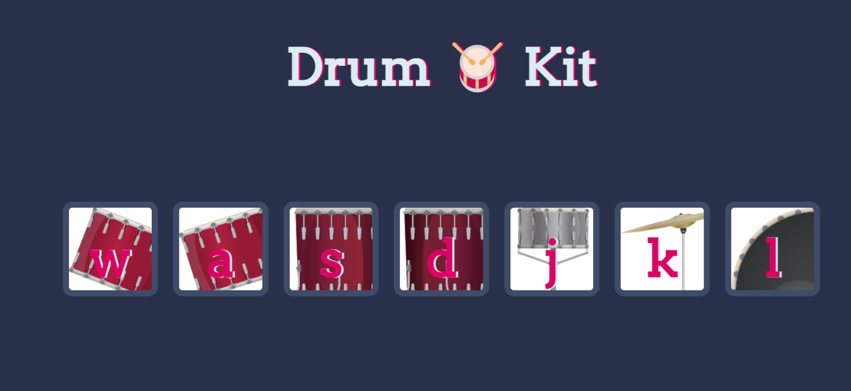

## *Drum Kit*

## jQuery

jQuery is a fast, lightweight, and feature-rich JavaScript library that simplifies web development. It provides an easy way to interact with HTML documents, handle events, create animations, and make asynchronous requests.

In native DOM, you use methods like document.querySelector(), document.querySelectorAll(), and getElementById() to select elements.

In jQuery, you often use CSS-style selectors to target elements. For example, $("button") selects all <button> elements.

To manipulate the selected elements: $("element-selector").method(), e.g., $("p").hide() hides all selected <p> elements.

To handle events: $("element-selector").on("event", function() { /* action */ }); e.g.,

$("button").click(function() { alert("Button clicked!"); });

**Task 2: Simon Game** using JavaScript and jQuery – The Simon game is a classic electronic memory game. It features four colored buttons, a speaker, a "Start" button, and a display.

The game generates a random sequence of button presses and tones. Players must replicate the sequence correctly to advance to the next level. If they make a mistake, the game ends.

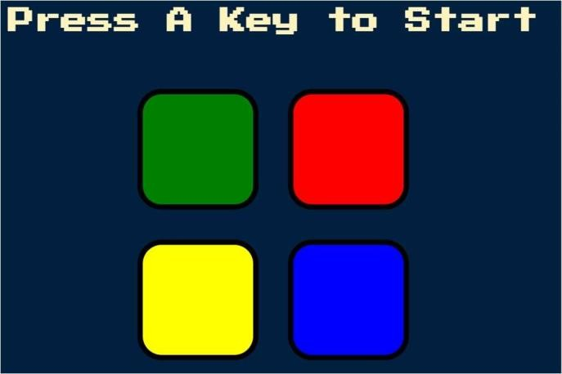



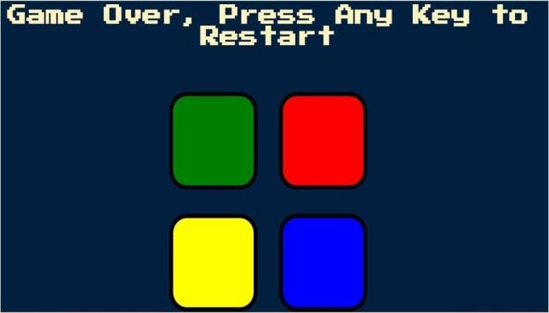

# *Simon Game*

## Express.js with Node.js

**Node.js:** Node.js is an open source , cross platform javascript runtime environment that allows you to execute javascript code on the server side. It was created by Ryan Dahl in 2009 and has since gained widespread popularity for building scalable and high performance web applications. It is Non blocking and Asynchronous. Npm is the default package manager for Node.js. It provides a vast ecosystem of open source libraries and modules that can be easily installed and used in Node.js applications. It simplifies package management and dependency handling. It is cross platform and single threaded.

**Express.js:** Express.js is a minimal and flexible Node.js web application framework that provides a set of features for web and mobile applications. While express itself doesn’t include a template engine, it can be easily integrated with popular template engines like EJS, Pug, and HandleBars. This allows you to generate dynamic HTML on the server and send it to the client.

#### Components:

Routing: Express.js provides a routing mechanism to handle HTTP requests and define the behavior of your application based on URLs. You can define routes using HTTP methods like GET, POST, PUT, DELETE, etc.

Middleware: It allows you to use functions to perform tasks in the request-response cycle, such as parsing request data, authentication, logging, and more.

Template Engines: You can use template engines like EJS to generate dynamic HTML content.

You can define your server to listen on a specific port and handle incoming requests. const express = require('express');

const app = express(); const port = 3000; app.get('/', (req, res) => {

res.send('Hello, Express.js!');

});

app.listen(port, () => {

console.log(`Server is running on port ${port}`);

## });

## Axios

Axios is a popular JavaScript library used to make HTTP requests from web browsers or Node.js applications. It provides a simple and consistent way to communicate with web servers and retrieve or send data.

Some important features of Axios:

* HTTP Requests: Axios can be used to send HTTP requests, including GET, POST, PUT, DELETE, and more. It supports the full range of HTTP methods.
* Promise-Based: Axios is built on top of JavaScript Promises. This means that when you make a request, you get a Promise object in return, which allows you to handle the response asynchronously using .then() and .catch().
* JSON Handling: Axios automatically parses JSON responses, making it easy to work with data from APIs. You can also send JSON data in the request body.
* Request and Response Interceptors: Axios allows you to intercept requests and responses, which can be useful for adding custom headers, handling errors, or other custom logic.

Example

import axios from 'axios'; axios.get('https://api.example.com/data')

.then((response) => {.log('Data received:', response.data);})

.catch((error) => {console.error('Error:', error); }); const postData = {

username: 'exampleUser', email: 'user@example.com',

};

axios.post('https://api.example.com/post-endpoint', postData)

.then((response) => { console.log('POST request successful:', response.data);})

.catch((error) => {console.error('POST request error:', error);});

## Task 3 : BoredApp is an application to understand and use AXIOS. This application let’s the user choose type of activity and number of participants and it calls <https://bored-api.appbrewery.com> API to get a random activity. This activity is then show to the user.

## 

## *BoredApp*

## Databases

### SQL

* + SQL databases are relational databases, meaning they use structured tables to store data.
  + Data is organized into rows and columns.
  + They are suitable for complex queries, transactions, and large datasets.
  + Popular SQL databases include MySQL, PostgreSQL, and SQLite.

### NoSQL – MongoDB and Mongoose

* + NoSQL databases are non-relational, and data can be stored in various formats: documents, key-value pairs, graphs, etc.
  + MongoDB is a popular NoSQL database that stores data in JSON-like documents.
  + It's flexible, scalable, and great for unstructured data.
  + MongoDB is often used with Mongoose, an Object Data Modelling (ODM) library for Node.js which simplifies database interactions in Node.js applications.

## Authentication and Security

* Introduction to Authentication: User authentication, which is the process of verifying the identity of users, typically through a username and password. It's essential for securing applications and data.
* Using Environment Variables to Keep Secrets Safe: Environment variables are used to store sensitive information like API keys and passwords securely by using dotenv package and storing secrets in .env file.
* Hashing Passwords: Hashing is a technique to convert passwords into a fixed-size string of characters, making it more secure.
* Salting and Hashing Passwords with bcrypt: bcrypt is a cryptographic hash function designed for secure password hashing. It uses techniques like salting, adaptive slowing, and one-way hashing to protect user passwords from various attacks, making it a popular choice for password security in applications. It's widely used in web development to securely store and verify passwords.
* Using Passport.js to Add Cookies and Sessions: Passport.js is a Node.js library for handling authentication.

# OAuth 2.0 & How to Implement Sign in with Google: OAuth 2.0 is a standard for authorization. This part is likely about integrating third-party sign-in options, such as Google account, using OAuth

# Chapter 4 : Project – Blog Website

## Project Description:-

The Blog website is web application designed to provide a comprehensive social website for providing Solaces (peaceful places) near you and around the world. It aims to provide a user friendly environment for sharing solaces to the users of the website. The website’s primary purpose is to offer a collection of blogs/destinations where users can explore and read and mentally immerse themselves in the peaceful places.

## Problem Statement :-

In today’s world, there is a growing demand for digital spaces that offer relaxation, inspiration, and guidance for those seeking peace, both in their travel experiences and in their everyday lives. It plays a role in promoting mental wellness, supporting tourism, and creating a sense of community among its users. This blog website provides this need by delivering a user friendly platform for people around the world to share solaces with other users to explore.

1. **Mental Health and Well-Being**: In today's fast-paced and often stressful world, people increasingly seek ways to improve their mental health and well-being. Such websites provide a digital refuge where users can momentarily escape, relax, and find inspiration to lead a more peaceful life.
2. **Travel and Exploration:** Many people have a desire to explore and discover new destinations that offer tranquility and serenity. Websites like this serve as a guide, helping users find places that may not be well-known or easily accessible.
3. **Inspiration and Relaxation:** Peaceful blogs and content can inspire people to explore new destinations, practice mindfulness, and adopt a more balanced lifestyle. The content on such websites can be a source of relaxation and stress relief.
4. **Community and Sharing**: These websites often have social features that allow users to connect with like-minded individuals, share their experiences, and engage in discussions about peaceful living, travel tips, and mindfulness prac

## Objectives: -

1. **Blogs**: Curated blogs that highlight peaceful destinations, nature getaways, and urban havens.A diverse range of content, including travel experiences, mindfulness tips.
2. **User-contributed content**: allowing members to share their serene experiences and travel tales.
3. **Immersive:** Visuals High-quality images that transport users to peaceful destinations.
4. **User Profiles**: User registration and login functionality.
5. **Community and Social Features**: A review section in blog for users to share their thoughts on the blog or place. Users can rate and review the blog, helping others find the best locations for serenity.
6. **Geographical location:** Represent exact location of the place mention in the blog in a map box.

## Technology Used:-

1. HTML CSS
2. JavaScript
3. MERN (MongoDB, Express, React and Node.js)
4. Embedded JavaScript

## Other Packages Used: -

1. @mapbox/mapbox-gl-geocoder
2. cloudinary
3. connect-flash
4. dotenv
5. ejs
6. ejs-mate
7. express
8. express-session
9. joi
10. mapbox-gl
11. method-override
12. mongoose
13. multer
14. multer-storage-cloudinary
15. passport
16. passport-local
17. passport-local-mongoose
18. path

## Features :-

1. **User Authentication:** New user registration and existing user login functionality to create and access accounts securely.
2. **Reviews:** Allow users to add, delete comments on a particular blog. Along with reviews, users can also give a rating to the blog in accordance with how much peaceful they find the place shown.
3. **View all blogs:** Users, whether authenticated or not, can view all the blogs posted on the website. Only authenticated users will be able to add a review to a blog.
4. **Create Blog:** Users who are authenticated can create a new blog which will be made public as soon as it is posted. The creator of the blog will have access to edit or delete the blog.
5. **Geolocation:** The full view of a blog will also show the geolocation of the place mentioned in the blog on a mini-map box.
6. **Routing between different pages:** Users can route between different pages: home page, create blog page, view all blogs pages, user log in, log out and register page.
7. **Immersive:** high quality images of the place will also be shown on a sliding window. Users will have functionality to traverse through the images.

# Chapter 5 : Snapshots

1.Register Page

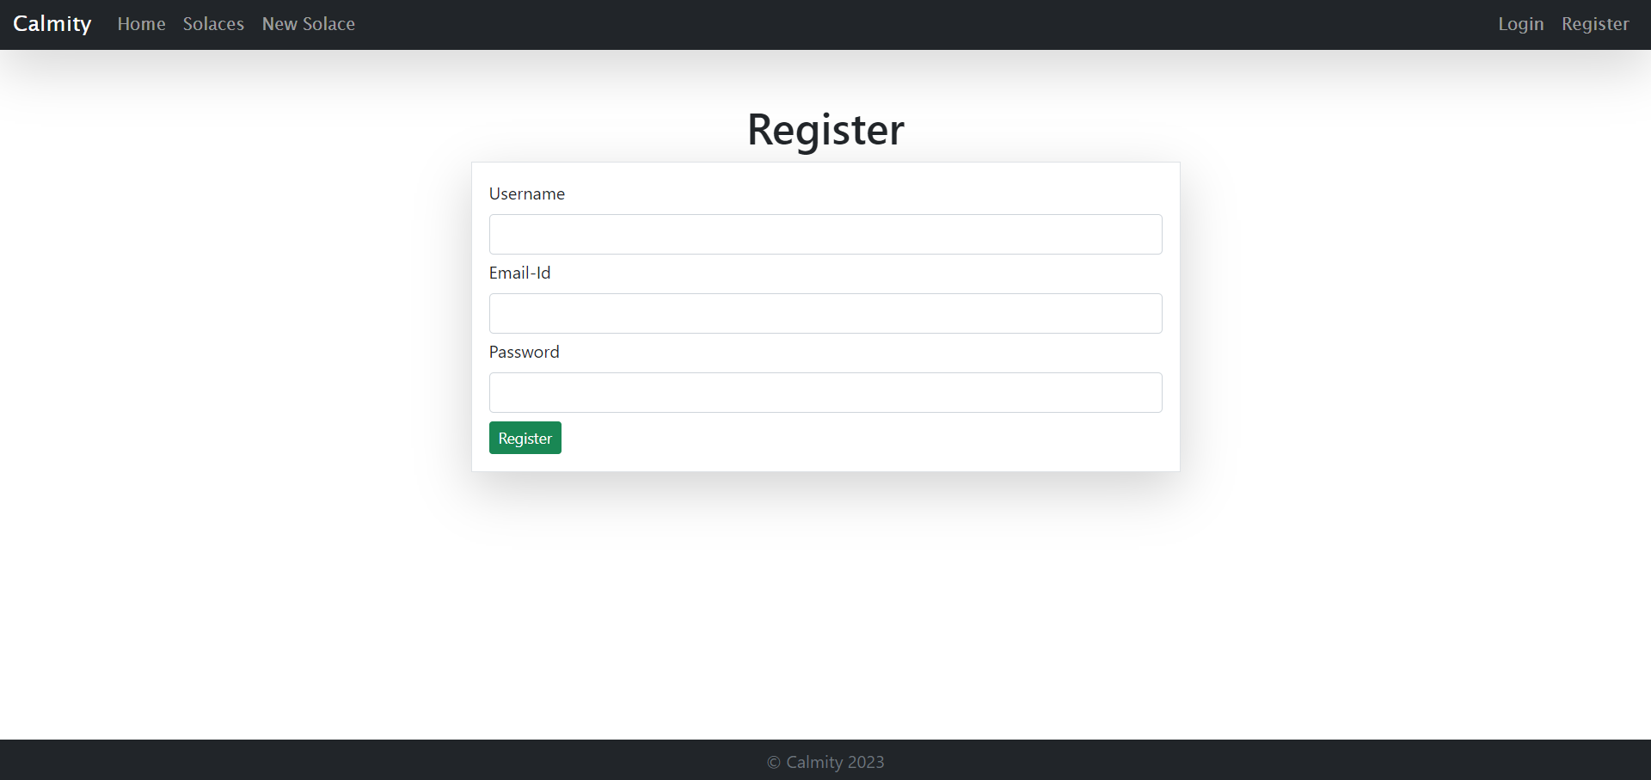

1. Login Page

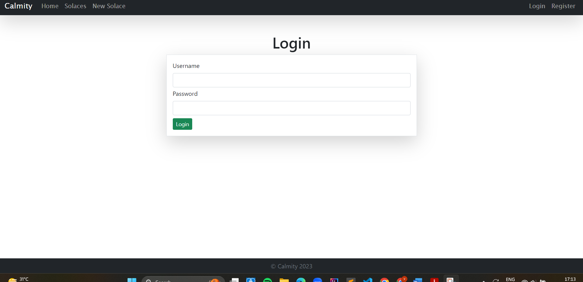

1. Home Page



1. View all blogs Page

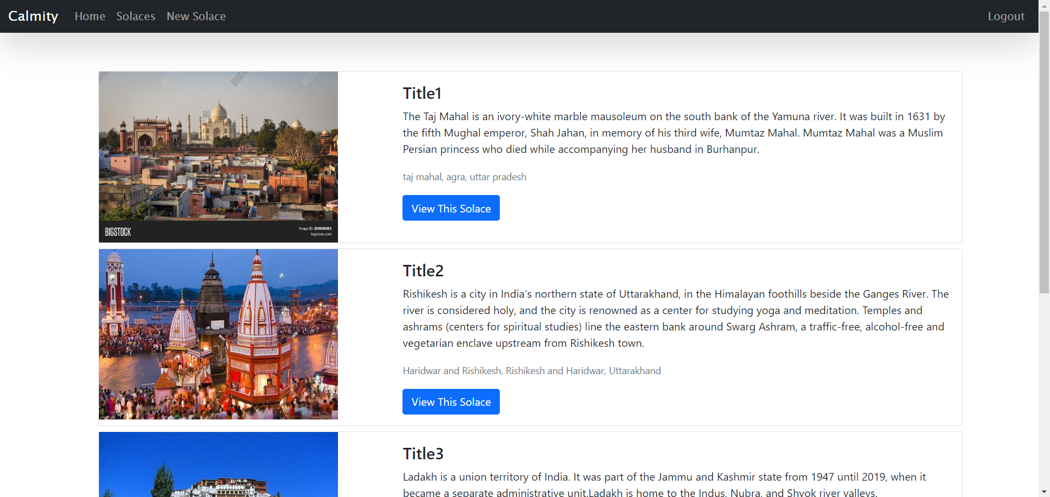

1. New Blog page

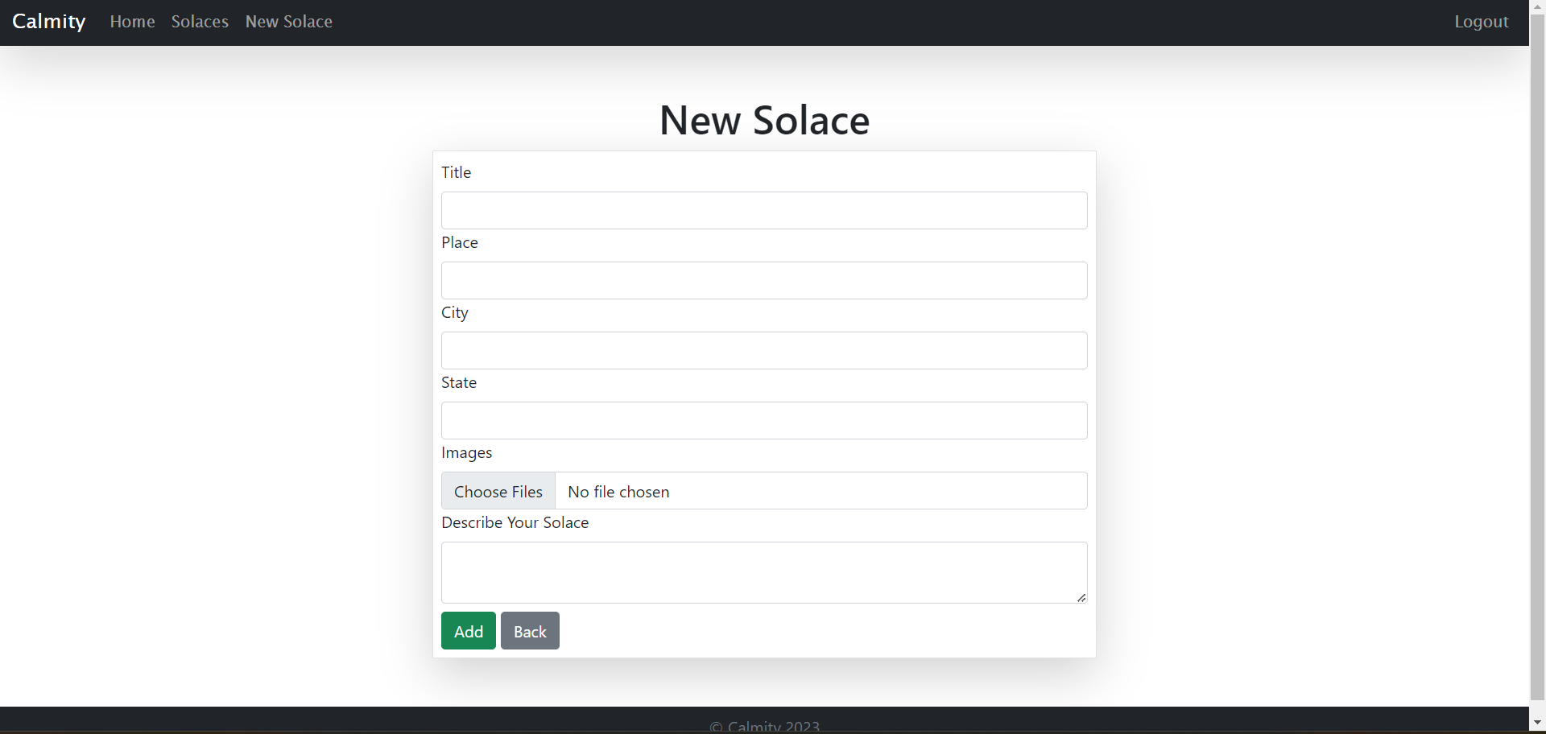

6.Selecting image from the computer

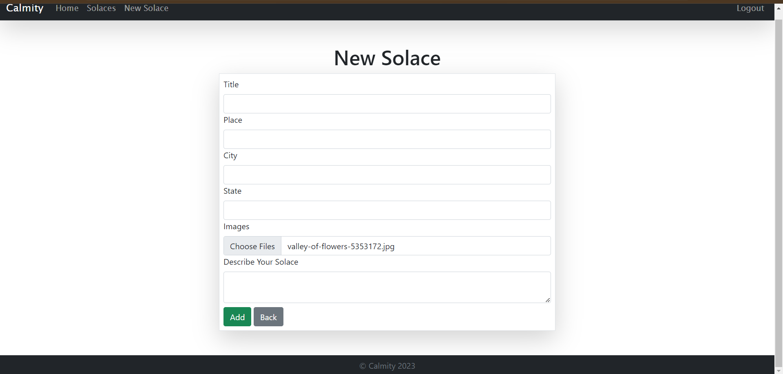

7.Full view of blog

7.1. The blog

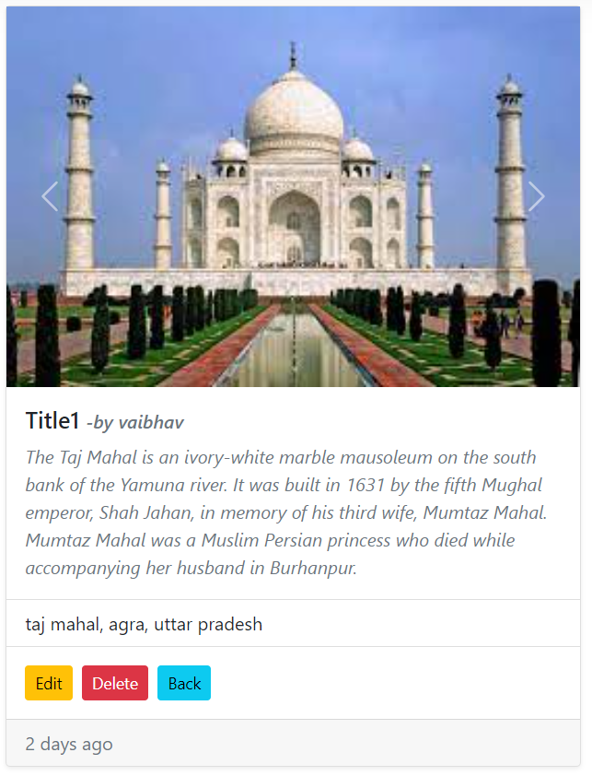

7.2 Map-box showing geographical location of the place

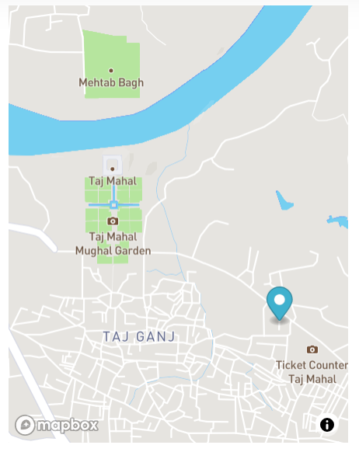

7.3 The review section of the blog.

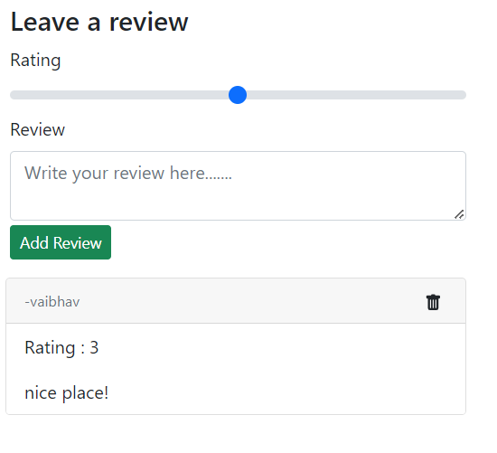

7.4 Full view

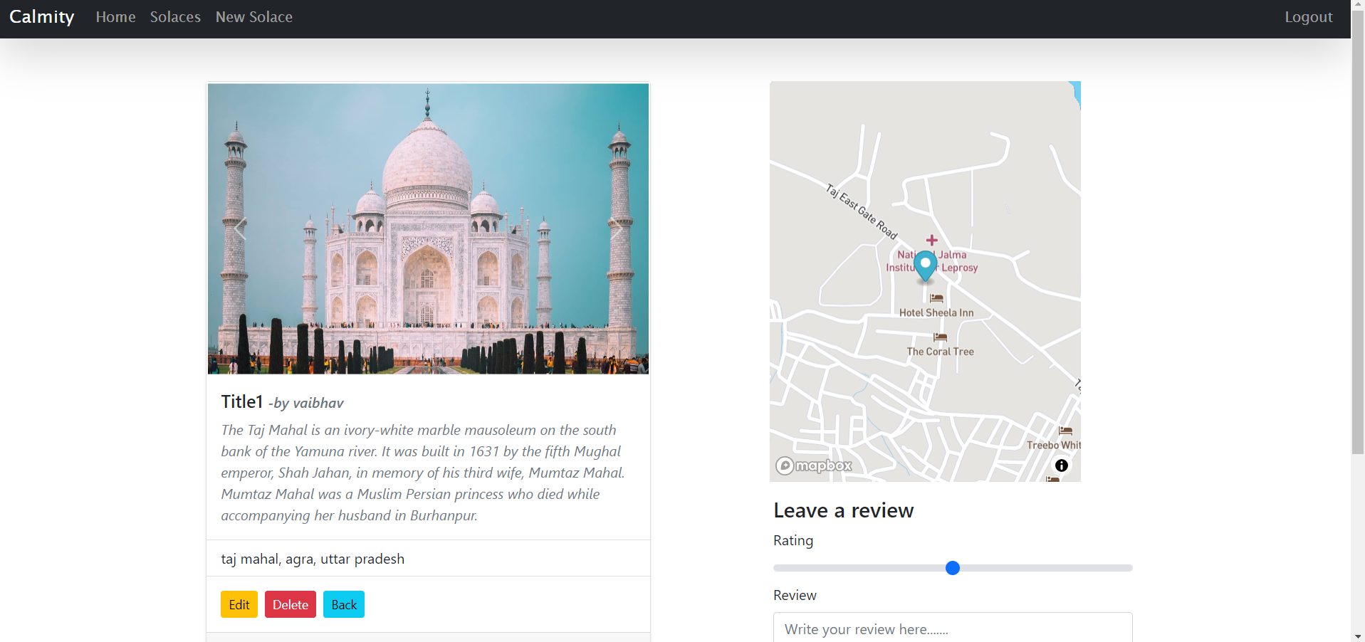

1. Edit Solace

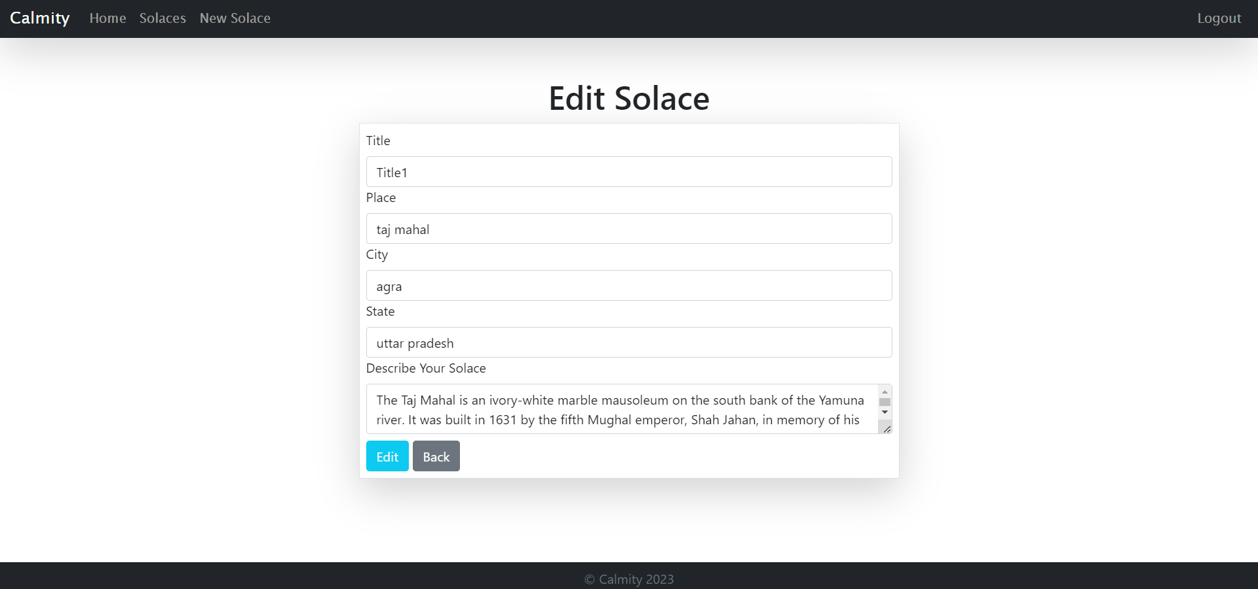

# Chapter 6 : Results And Discussions

Web Development Bootcamp includes a comprehensive distinction between tools and technologies for front-end and back-end development.

Furthermore, we were introduced popular programming languages and frameworks utilized in web development, such as HTML, CSS, JavaScript, Node.js, React, and Bootstrap. Their explanation of how websites function, including DNS, HTTP requests, and the assembly of web content, provides a clear understanding of the web development process.

Front-end technologies included HTML, CSS, and JavaScript. Additionally, advanced concepts like React and React Hooks have also been covered. In terms of back-end development, Node.js and Express.js are presented as server-side technologies, complemented by discussions on REST APIs, databases (SQL and NoSQL - MongoDB), and authentication services using Google OAuth and Passport.js.

Introduced to Git and GitHub for version control, and touched on blockchain technology's potential applications.

In the projects section, we presented various practical web development endeavors, ranging from a personal website developed using HTML and CSS to a Simon game created using JavaScript and jQuery. The Drum-Kit application, constructed using JavaScript ,HTML, CSS, has also been included.

In the final project, a comprehensive project involving the development of a Blog website using the MERN stack. The project emphasizes user authentication, and a variety of features to enhance the blogging experience.

In conclusion, the information provided serves as a robust foundation for understanding web development concepts, tools, technologies, and practical projects. It underlines the significance of user authentication and data security. The description of the blog website demonstrates the practical application of the discussed concepts and technologies. This comprehensive knowledge base is valuable for individuals interested in pursuing a career in web development or exploring these technologies for personal projects.

# Chapter 7 : Conclusions And Future Scope

The future scope of web development promises an exciting evolution driven by key trends and technologies :-

1. **AI and Machine Learning:** Integration of AI and ML into web applications is on the rise. This enables personalized experiences, such as tailored content recomendations and chatbots for enhanced user interactions.
2. **Cross-Platform Development:** Frameworks like React Native and Flutter will remain vital for building web and mobile applications simultaneously. This cross- platform approach streamlines development and reaches a broader audience.
3. **Web3 and Blockchain:** Decentralized applications (DApps) on platforms like Ethereum offer exciting opportunities. They provide secure, transparent, and trustless systems for a wide range of industries beyond cryptocurrencies.
4. **Cybersecurity and Data Privacy:** As the digital landscape evolves, concerns about data security and privacy will continue to grow. Web developers will play a crucial role in ensuring the protection of user data.
5. **Voice and Conversational Interfaces:** Conversational interfaces and voice-powered web apps are becoming more prevalent. Users can interact with applications using natural language, making the user experience more intuitive and accessible.
6. **UI/UX Design**: A basic understanding of user interface (UI) and user experience (UX)design principles can enhance a developer's profile and help in creating user- friendly websites.
7. **Website Performance Optimization**: Knowing how to optimize website loading times and overall performance is a skill that will always be appreciated by clients.
8. **Web Accessibility**: Ensuring websites are accessible to all, including people with disabilities, is gaining importance. Knowledge of accessibility standards and tools will be valuable.

# Chapter 8 : Weekly Job Summary

Week:1

|  |  |  |  |
| --- | --- | --- | --- |
| ***Description of activity, task, duty or***  ***responsibility*** | ***Performed with***  ***Team*** | ***Performed***  ***Alone*** | ***Time Spent***  ***(hours)*** |
| HTML | NO | YES | 3 |
| CSS | NO | YES | 5 |
| Flexbox, Grid | NO | YES | 3 |

Week:2

|  |  |  |  |
| --- | --- | --- | --- |
| ***Description of activity, task, duty or***  ***responsibility*** | ***Performed with***  ***Team*** | ***Performed***  ***Alone*** | ***Time Spent (hrs)*** |
| Bootstrap | NO | YES | 3 |
| JavaScript | NO | YES | 6 |
| Task-1 : Drum-Kit | NO | YES | 3 |

Week:3

|  |  |  |  |
| --- | --- | --- | --- |
| ***Description of activity, task, duty or***  ***responsibility*** | ***Performed with***  ***Team*** | ***Performed***  ***Alone*** | ***Time Spent***  ***(hours)*** |
| DOM , jQuery | NO | YES | 6 |
| Task 2 : Simon Game | NO | YES | 5 |

Week:4

|  |  |  |  |
| --- | --- | --- | --- |
| ***Description of activity, task, duty or***  ***responsibility*** | ***Performed with***  ***Team*** | ***Performed***  ***Alone*** | ***Time Spent***  ***(hours)*** |
| Node, Express ,EJS | NO | YES | 5 |
| Git, Github Version Control | NO | YES | 3 |
| APIs | NO | YES | 4 |

Week:5

|  |  |  |  |
| --- | --- | --- | --- |
| ***Description of activity, task, duty or***  ***responsibility*** | ***Performed with***  ***Team*** | ***Performed***  ***Alone*** | ***Time Spent***  ***(hours)*** |
| Task 3: BoredApp | NO | YES | 4 |
| Databases, Mongoose, MongoDB | NO | YES | 3 |
| Working with Databases | NO | YES | 4 |

Week: 6

|  |  |  |  |
| --- | --- | --- | --- |
| ***Description of activity, task, duty or***  ***responsibility*** | ***Performed with***  ***Team*** | ***Performed***  ***Alone*** | ***Time Spent***  ***(hours)*** |
| Authentication and Security | NO | YES | 5 |

# Learning after Training

After completing web development training, I gained valuable insights and experiences that facilitate career advancement and staying current in this rapidly evolving field. These pivotal learnings include:

1. **Continuous Learning**: In web development, staying updated about the latest technologies, tools, and trends is necessity. Regular exploration of new languages, frameworks, and libraries is essential.
2. **Hands-On Experience**: Practical application of acquired knowledge through real- world projects is invaluable for skill enhancement.
3. **Problem-Solving Skills**: Developing robust problem-solving abilities is much needed for efficient problem resolution.
4. **Proficiency in Database Management**: Competence in working with both SQL and NoSQL databases is crucial for effective data storage and administration.
5. **Client-Server Interaction**: Understanding the dynamics of client-server interactions and adeptness in making asynchronous requests and handling client-side data are foundational skills.
6. **Coding Standards**: Complying with coding standards and best practices ensures the creation of clean, maintainable, and efficient code.
7. **Responsive Design:** Grasping the principles of responsive web design enables the development of websites that seamlessly adapt to various devices and screen sizes.
8. **Specialization Consideration**: Reflect on specialization in a particular domain, such as front-end development, back-end development, full-stack development, or a specific framework or technology.
9. **Contributing to Open Source**: Participation in open-source projects fosters learning from experienced developers and aids in building a portfolio.

# References

1. https://[www.udemy.com](http://www.udemy.com/)
2. https://[www.appbrewery.com](http://www.appbrewery.com/)
3. https:/[/www.w3schools.com](http://www.w3schools.com/)
4. <https://developer.mozilla.org/en-US/>
5. https://www.npmjs.com/